F.4 Making Biological Drawing – Mastery Teaching Work Sheet ____ June 2020

Step 1: Write down the title, plane of view, magnification power.

Step 2: Identify the structures related to the questions.
L.P.: distribution of tissues
H.P.: individual cell

Step 3: Draw the outline (resemblance)
Pencil
Centralize the drawing on the paper
Line should be thin, firm, smooth, continuous, with even thickness
Free hand

Step 4: Add the details (shape, proportion)
May need to use H.P. for observation

Step 5: Add labels / annotation

Labels should be evenly distributed, not inside the drawing
Labeling lines: straight (use ruler), no crossing, no arrow-head
Simple prints (no block letters)
Annotations: as required by the question

Good example: Not a good example:
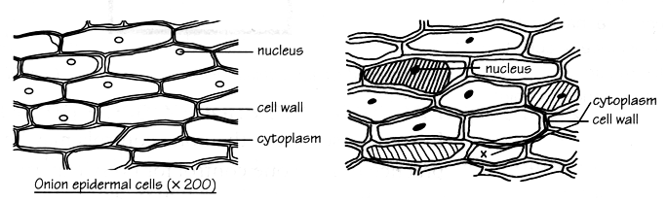

All parts should be in correct proportion:
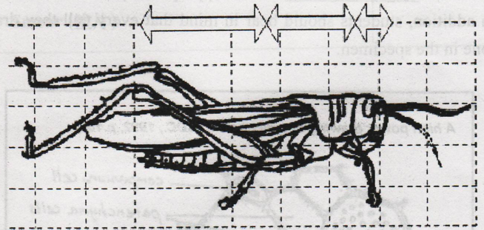

Modelling

Make a low power drawing of a Helianthus stem to show the tissues involved in transport of substances in the plant. Label and annotate your drawing appropriately.

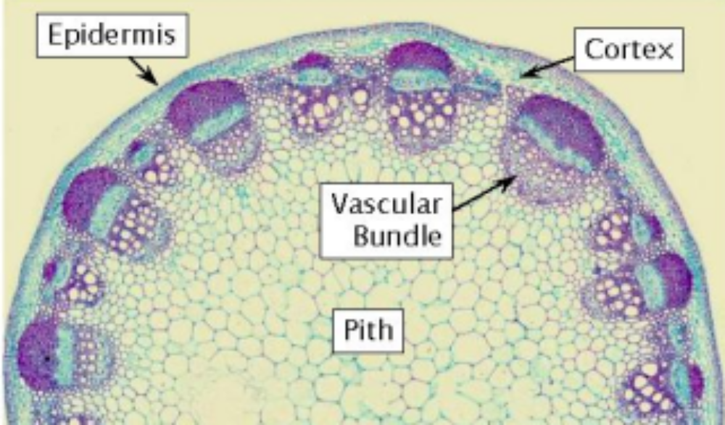
(x 40)

Some magnified photomicrograph of the vascular bundle for reference:
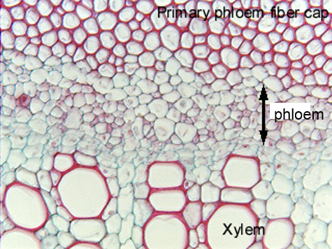
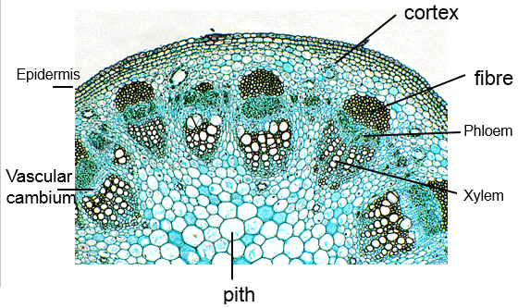
(x 100)
(x400)
Vascular cambium

Guided Practice
Draw a low power drawing of dicotyledonous root to show the tissues involved in transport of substances. Label and annotate your drawing appropriately.

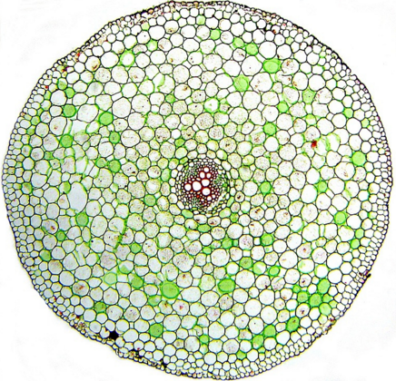

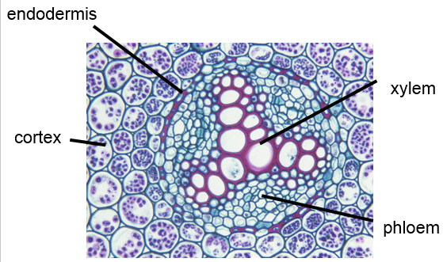

(x400)

(x100)

Individual Practice
Draw a low power drawing of a dicotyledonous leaf to show tissues involved in transport.
Label and annotate your drawing appropriately.

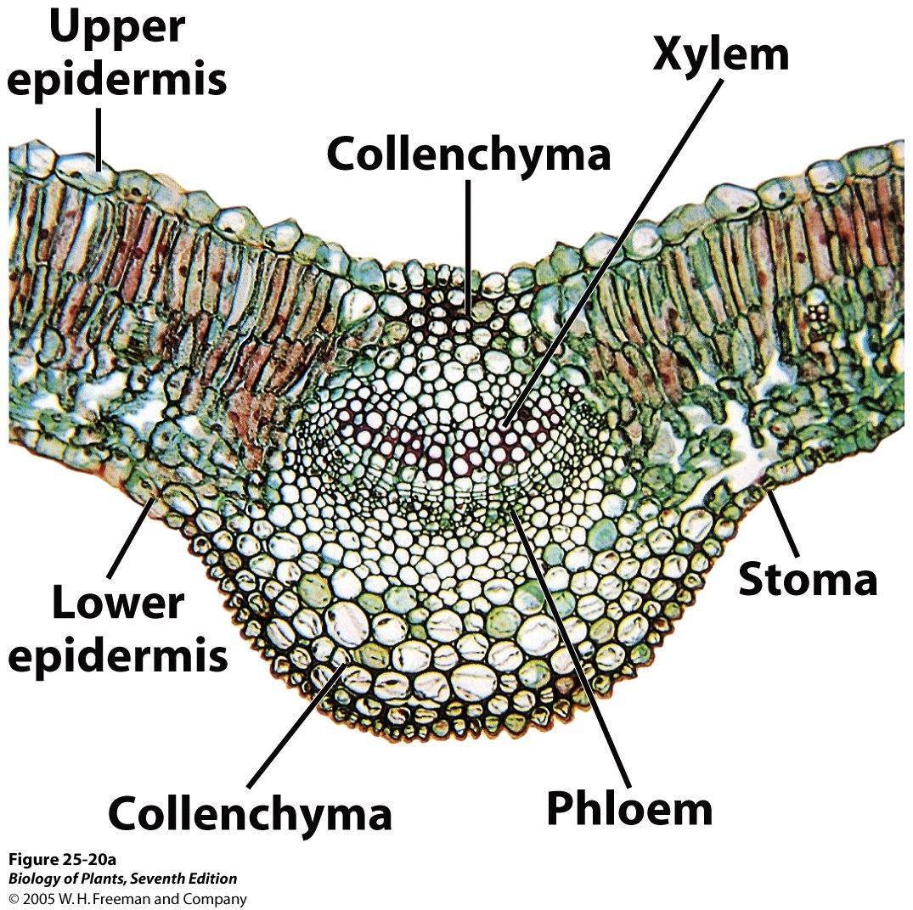
(Thick-wall cell)
(x100)

